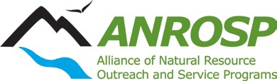
Outstanding Volunteer Project Award

Application due AUGUST 15th
Please submit to: Mark Larese-Casanova marklc@usu.edu
(If you do not receive confirmation email from Mark, he did not receive your application)

Provide the information below in a single document
- Award Category:
- Nominator’s Information:
Name:
Title:
Address:
Telephone:
Email Address:
- ANROSP member participants: List names and program affiliations for all ANROSP members involved in the program.
- Do you want the nomination materials returned to you (if not sent in digitally)? YES/ NO
- Describe the project and provide specific reasons/ examples of how the project has met each applicable criterion in the last 12 months (not to exceed 500 words/ 1 page plus copies of relevant project products, if applicable):
  - Describe the project (provide copy of relevant project products, if relevant).
  - Natural resources management - How does this project help solve real-world management challenges? (12 points)
  - Education - How does this project promote education of natural resources and/or the local environment? (12 points)
  - Research - What kinds of research and monitoring were included in this project? (4 points)
  - Partners - Which partners and local resources utilized to implement the project? (8 points)
  - Sustainability - How will the impacts of this project be maintained into the future? (4 points)

