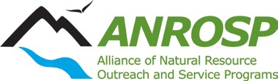
Outstanding Team Award

Application due AUGUST 15th
Please submit to: Mark Larese-Casanova marklc@usu.edu
(If you do not receive confirmation email from Mark, he did not receive your application)

Provide the information below in a single document
- Award Category:
- Nominator’s Information:
Name:
Title:
Address:
Telephone:
Email Address:
- ANROSP member participants: List names and program affiliations for all ANROSP members involved in the program.
- Do you want the nomination materials returned to you (if not sent in digitally)? YES/ NO
- Provide specific reasons/ examples of how the team has met each applicable criterion in the last 12 months (not to exceed 1500 words/ 3 pages):
  - Leadership - How does the team leadership inspire exceptional achievements? (12 points)
  - Dedication - How has steadfast focus of effort led to accomplishment of goals? (4 points)
  - Creativity - How does the team demonstrate innovation in pursuit of goals? (8 points)
  - Synergy - How does the team work together to exceptional performance? (8 points)
  - Evaluation - How does the team document outcomes and impacts? (8 points)
  - Performance - How does the team go above and beyond normal requirements? (4 points)
  - Any other factors which contribute to making the nominee an outstanding volunteer or team, such as consistent reliability and productivity (4 points)

